

**Capstone Project Report**

**Report 4 – Software Design Document**

– Hanoi, August 2019 –

**Table of Contents**

I. Project Report 3

1. Status Report 3

2. Team Involvements 3

3. Issues/Suggestions 3

II. Software Design Document 4

1. Overall Description 4

1.1 Assumptions 4

1.2 Design Constraints 4

1.3 [Technology Suggestion] 5

2. System Architecture Design 5

2.1 Overall Architecture 5

2.2 System Architecture 5

2.3 Package Diagram 5

3. System Detailed Design 6

3.1 <Feature Name1> 6

4. Data & Database Design 8

4.1 Database Design 8

4.2 Data File Design 9

# I. Project Report

## 1. Status Report

|  |  |  |  |
| --- | --- | --- | --- |
| **#** | **Work Item** | **Status** | **Notes (Work Item in Details)** |
| 1 |  | Pending |  |
| 2 |  | In Progress |  |
| 3 |  | Completed |  |

## 2. Team Involvements

|  |  |  |  |
| --- | --- | --- | --- |
| **#** | **Task** | **Member** | **Notes (Task Details, etc.)** |
| 1 |  | KienNT |  |
| 2 |  | TuanTV |  |
| 3 |  | AnhLM |  |

## 3. Issues/Suggestions

|  |  |  |  |
| --- | --- | --- | --- |
| **#** | **Issue** | **Status** | **Notes (Solution, Suggestion, etc.)** |
| 1 |  | Pending |  |
| 2 |  | In Progress |  |
| 3 |  | Completed |  |

# II. Software Design Document

## 1. Overall Description

### 1.1 Assumptions

[Describe any items, based on which to design future system. These may concern such issues as:

* Related software or hardware
* Operating systems
* End-user characteristics
* Possible and/or probable changes in functionality

Example:

This system is designed basing on these following assumptions:

* Windows XP
* Internet Explorer 6.0
* Acrobat Reader 6.0
* SQL Server 2000
* …
* ]

### 1.2 Design Constraints

[Describe any global limitations or rules that have a significant impact on the design of the system's software (and describe the associated impact). Such constraints may be imposed by any of the following (the list is not exhaustive):

* End-user environment.
* Availability or volatility of resources
* Standards compliance
* Interoperability requirements
* Interface/protocol requirements
* Data repository and distribution requirements
* Security requirements (or other such regulations)
* Memory and other capacity limitations
* Performance requirements
* Network communications
* Verification and validation requirements (testing)
* Other means of addressing quality goals
* Other requirements described in the requirements specification

Example:

This system should be complied with following items:

* Use AJAX to transfer data from browser to server.
* Every process in this system must be less than 10s.
* …]

### 1.3 [Technology Suggestion]

*[This section is optional. If this section isn’t set, remove it out of the document.*

*Purpose:*

*Provides outline of the emerging technologies that are expected to be available, and how they may impact the future development of the system architecture; This section is only for reference, not required.*

*Example:*

*Use Windows service to integrate between this system and door system.*

*….*

*]*

## 2. System Architecture Design

### 2.1 Overall Architecture

*[Select suitable architecture style and describe the architectural diagram in the relationship/connection to the external systems. The content of this section include the overall diagram and the explanation for each of the diagram components]*

### 2.2 System Architecture

*[Select suitable architecture patterns for sub-systems. The content of this section include the overall diagram and the explanation for each of the diagram components]. For example: with the layer pattern, we need to provide the description for each of the layers and the relationship among the layers]*

### 2.3 Package Diagram

*[Provide the package diagram for each sub-system. The content of this section include the overall package diagram(s) and the explanation for each package. Please see the sample and description table format below]*

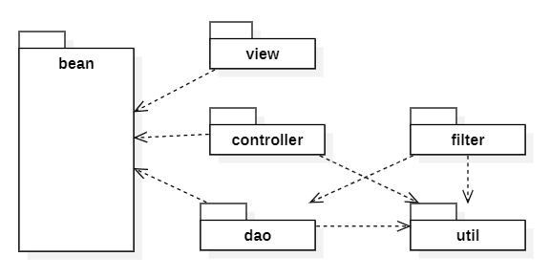

|  |  |  |
| --- | --- | --- |
| **No** | **Package** | **Description** |
| 01 | <Package name> | <Description of the package> |
| 02 |  |  |

## 3. System Detailed Design

### 3.1 <Feature Name1>

*[Provide the detailed design for the feature <Feature Name1>. It include Class Diagram, Class Specifications, and Sequence Diagram(s)]*

#### a. Class Diagram

*[This part presents the class diagram for the relevant feature]*

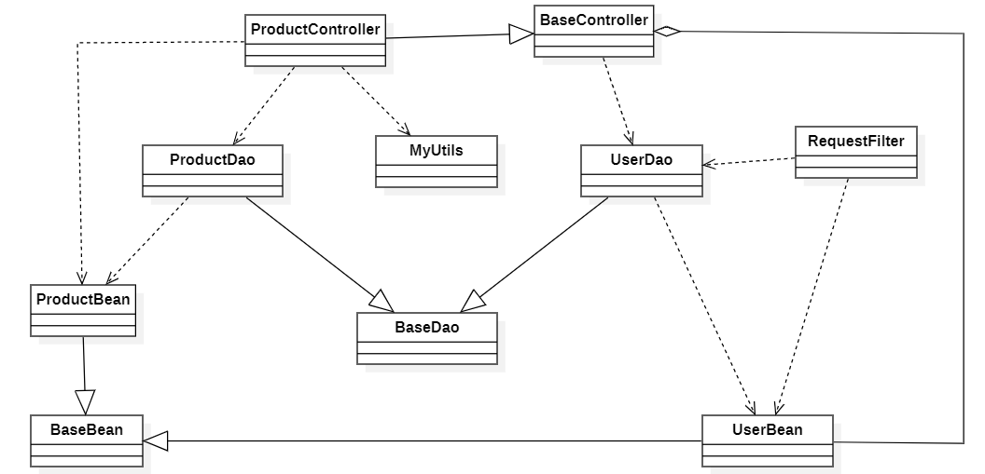

#### b. Class Specification

*[Provide the description for each class, including both Class Attributes and Class Methods information. Those can be in the table format as below]*

##### b1. XYZ Class

*[Provide the detailed description for the class methods]*

|  |  |  |
| --- | --- | --- |
| **No** | **Method** | **Description** |
| 01 | <method name> | <Description of the method, including the inputs, outputs & internal method processing> |
|  |  |  |

##### b2. ABC Class

***Class Methods***

*[Provide the detailed description for the class methods]*

|  |  |  |
| --- | --- | --- |
| **No** | **Method** | **Description** |
| 01 | <method name> | <Description of the method, including the inputs, outputs & internal method processing> |
|  |  |  |

##### b3. …

#### c. Sequence Diagram(s)

*[Provide the sequence diagram(s) for the feature, see the sample below]*

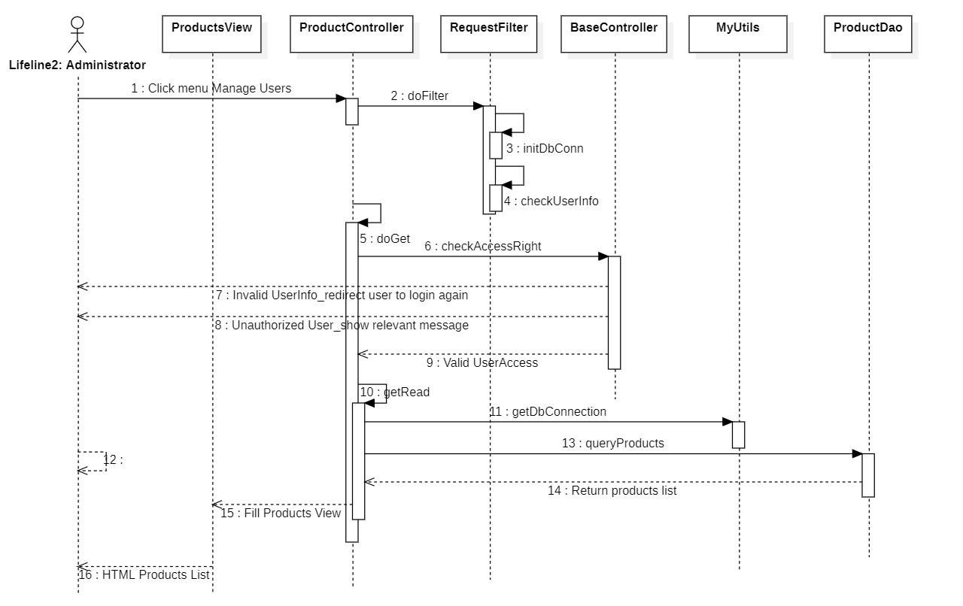

## 4. Data & Database Design

### 4.1 Database Design

*[Provide the tables relationship like example below]*

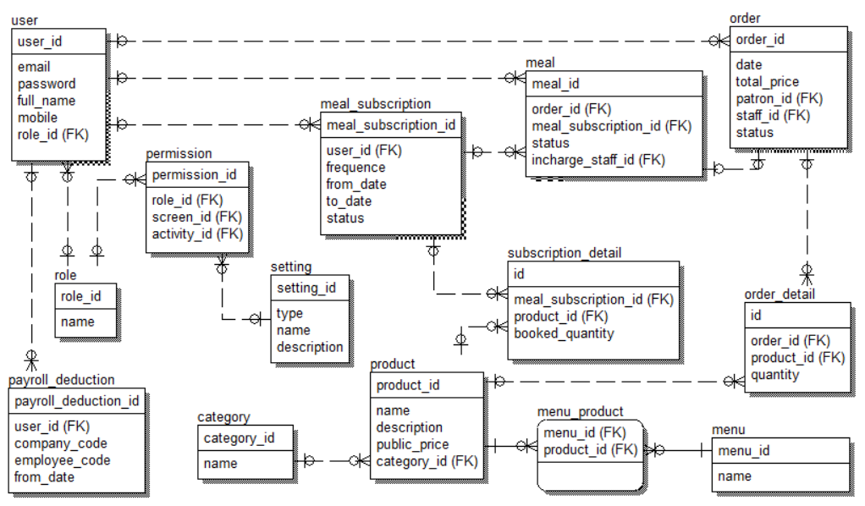

#### a. Table name 1

*[Give some lines about the table here>>*

*[Table fields, in the form of table format as below]*

|  |  |  |  |  |  |  |
| --- | --- | --- | --- | --- | --- | --- |
| **Field name** | **Type** | **Size** | **Unique** | **Not Null** | **PK/FK** | **Notes** |
| Field name1 |  |  |  |  |  |  |
| Field name2 |  |  |  |  |  |  |

#### b. Table name 2

…

### 4.2 Data File Design

*[File List, in the table format as below]*

|  |  |  |  |
| --- | --- | --- | --- |
| **#** | **File Name** | **Type** | **Notes** |
|  | Class name1 |  |  |
|  | Class name2 |  |  |